**Cross region replication (CRR)**

1. When we upload the object in Mumbai, the object should also be available in Sydney.
2. As we are replicating an object in another region, it is called cross region replication. (vice-versa will not happen)

If we delete object in Mumbai, it will not be deleted in Sydney.

If we edit object in Mumbai, it will not be edited in Sydney.  
**Hands-on:**

1. Enable CRR in Mumbai bucket

Select Mumbai bucket > Management > Replication Rules > Create Replication Rule > Enable Bucket versioning > Replication Rule Name - CRR1 > Destination bucket > Sydney bucket > Enable versioning

This rule applies to all objects -- I Acknowledge

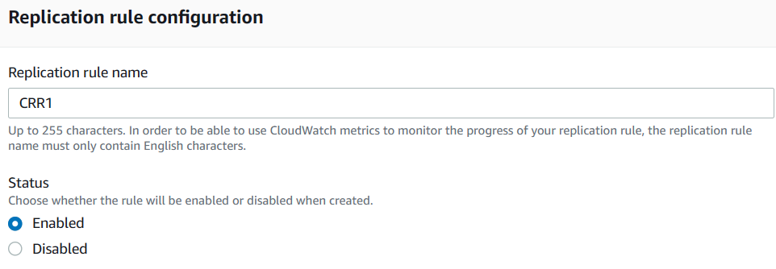

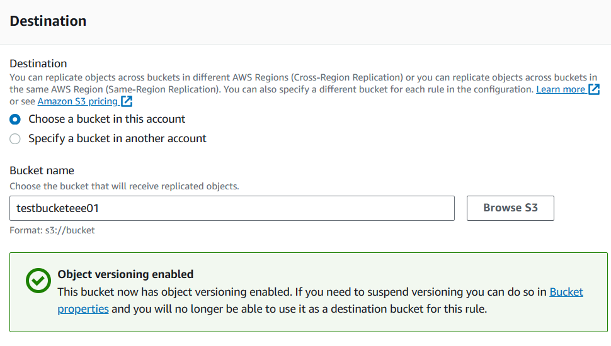

IAM Role (To establish connection between two regions, we need IAM role)

IAM Role - Create new role

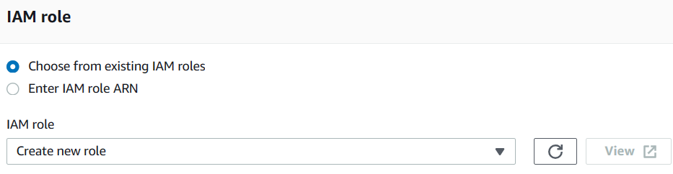

Save.

Now, upload the object in Mumbai bucket, it will be replicated in Sydney bucket!!!!

**Transfer Acceleration**

When we enable transfer acceleration, data will be transferred to edge location and then from edge location data will be transferred to bucket.

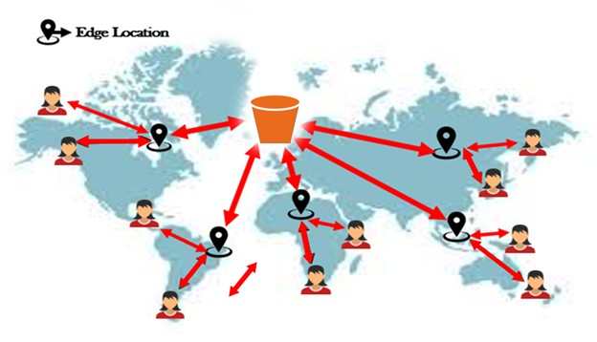

Select Mumbai bucket --->Properties ---> Transfer acceleration --->Edit ---> Enabled --- Save Changes.

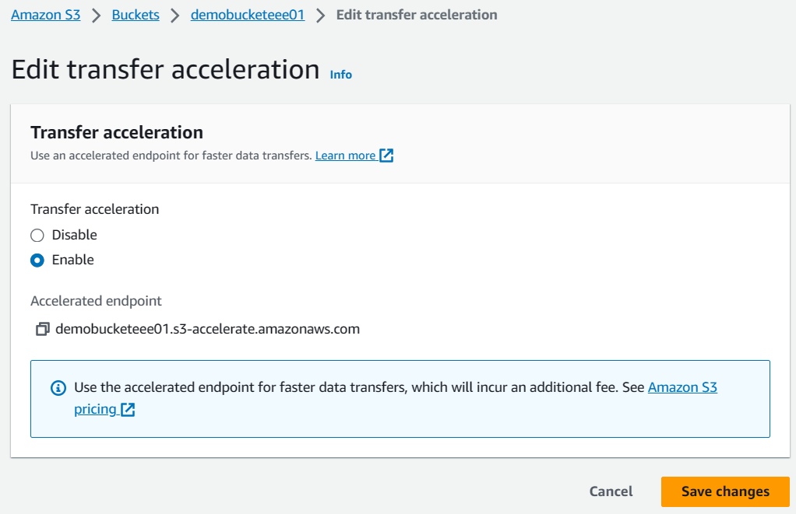

**How can we check the speed?**

Properties ---> Transfer acceleration ---> Learn More

Browse amazon S3 Transfer Acceleration Speed Comparison tool

---> want to compare your data transfer speed by region (open in new tab)

we can compare

S3 direct upload speed

S3 accelerated transfer upload speed.

In this case, we cannot find much difference.

But in longer distances, we can find the difference.

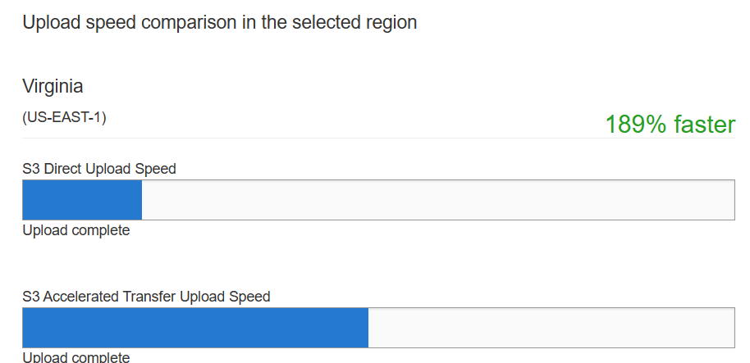

**Encryption**

* There are two types of encryptions:
  1. AES – 256 (Advanced Encryption Standard) - Single encryption.
  2. AWS - KMS (Key Management Service) - Double encryption for enhanced security.

Choose the desired encryption level (KMS recommended for higher security)

Default Encryption Settings:

* To enable encryption for a bucket, go to Bucket Properties, then Default Encryption, and click Edit to enable.

**Metadata and Tags**

* **Metadata:** Pre-defined key-value pairs providing information about the object (e.g., content type, language)
* **Tags:** User-defined key-value pairs for object customization
* **Access:** Viewable through object properties
* **Impact:** Enhances object discoverability and organization

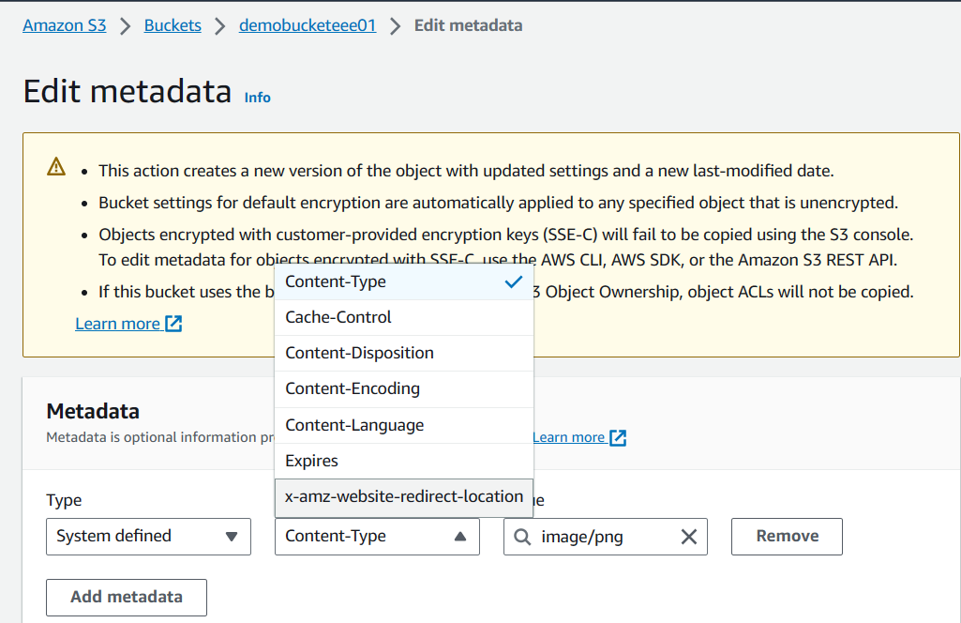

**Access Control (ACL) and Bucket Policy:**

* **ACL:** Controls object access at both bucket and object levels
* **Bucket Policy:** Controls bucket-level access
* **Grantee:** User or group granted access
* **Canonical ID:** Unique identifier for grantee
* **Application:**
  + **ACL:**
    - **Bucket level:** Select bucket -> Permissions tab -> ACL Edit -> Add grantee
    - **Object level:** Select object -> Permissions tab -> Add grantee
  + **Bucket Policy:** Define policy in JSON code and assign through Bucket -> Permissions tab
* **Impact:** Determines who can access and perform actions on buckets and objects

It’s the job of AWS administrator.

**Lifecycle Management:**

* **Purpose:** Automates object lifecycle transitions to optimize storage costs
* **Application:**
  + Create a new bucket
  + Select bucket -> Management tab -> Create lifecycle rule
  + **Define rule details:**
    - Rule name
    - Apply to all objects
    - Transit current version of objects between storage classes
    - Specify transition intervals and storage classes (e.g., Standard-IA, One Zone-IA)
* **Impact:** Automatically moves objects to different storage classes based on age and cost, reducing storage costs

Transit current version of objects between storage classes

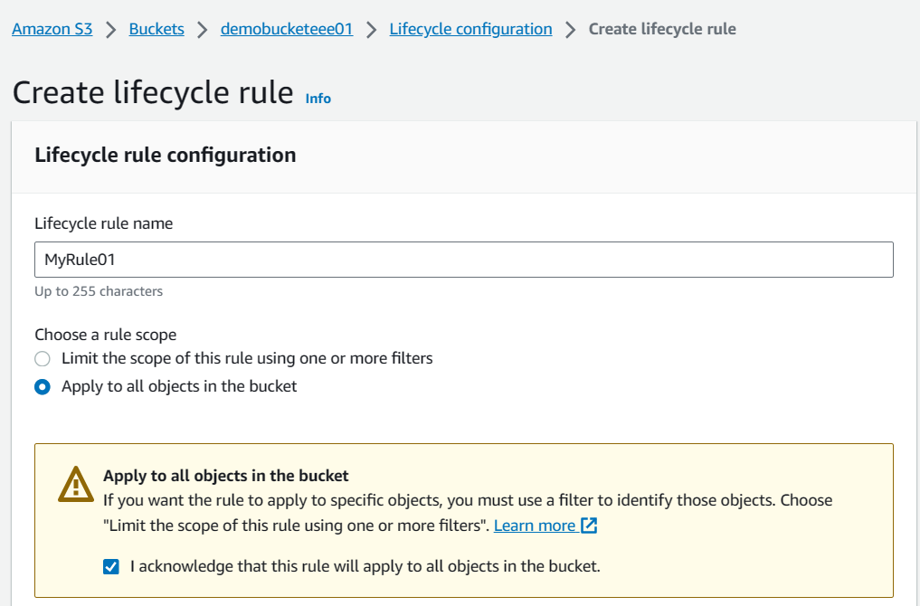

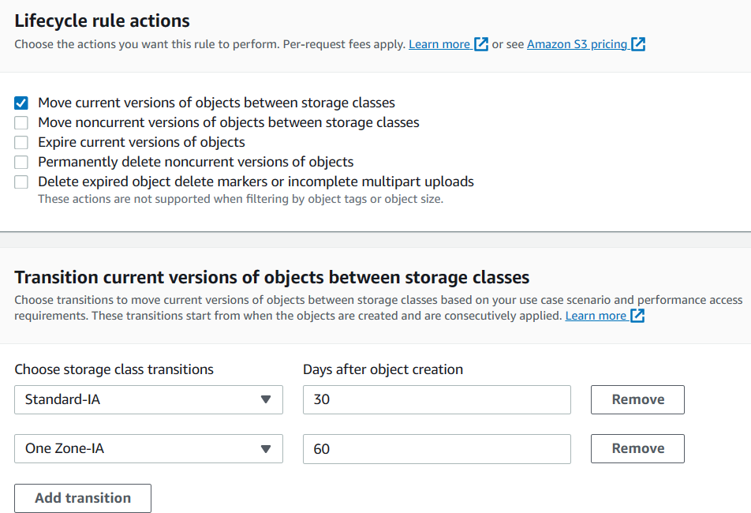

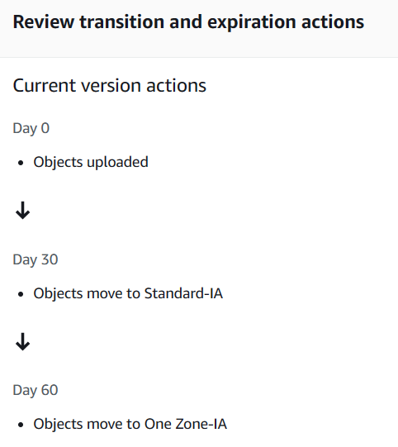

From now, any object uploaded in the bucket will follow the rule for transition.